James Young
100273383
CPSC 1160-001
Bijan Farrahi
Assignment 4

OUTPUT

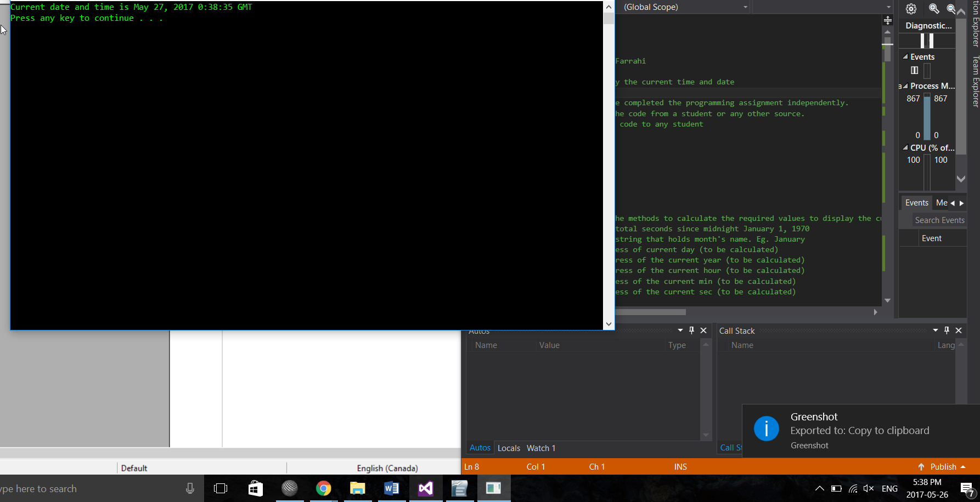
COUPLE OF SECONDS LATER
